**MS WORD (winword.exe)**

Microsoft Word is a word processor created by Microsoft. Word is used to create documents, Using word you can create professional resume, cover letters, flyers, and much more, You can use Mail Merge. Mail merge means to send personalized letters, labels, invitation etc. to the multiple recipient.

MS WORD USER INTERFACE

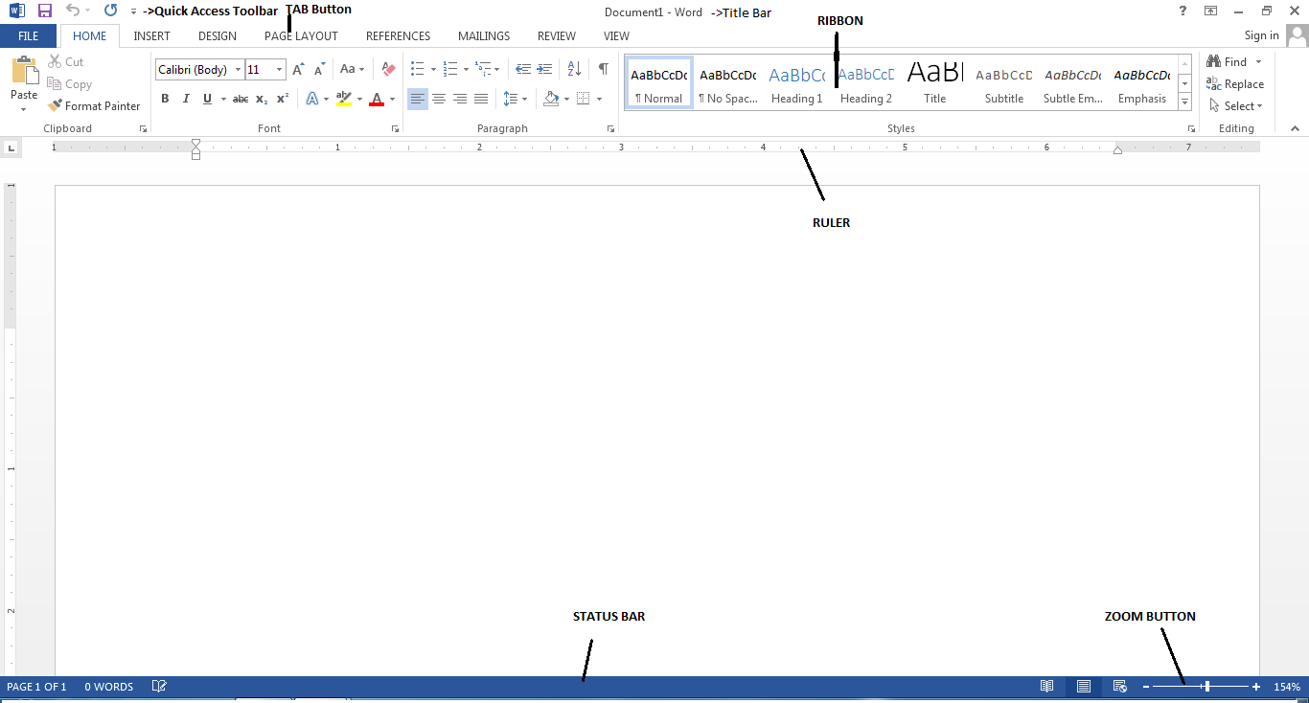

**MS word file extention**

Filename.docx(Ms office version 2007 onwards)

Filename.doc(Before Ms office version 2007)

**GENERAL PROGRAM SHORTCUT SHORTCUT**

FILE-NEW – TO CREATE A BLANK NEW DOCUMENT CTRL+N

FILE-OPEN-TO OPEN AN EXISTING DOCUMENT CTRL+O

FILE-SAVE-TO SAVE THE DATA PERMANENTLY CTRL+S

FILE-SAVE AS-TO SAVE THE FILE IN DIFERENT FILE FORMAT

(EX-PDF,XML OR TO SAVE IN OLDER VERSION OF MS OFFICE) F12

PRINT-TO PRINT THE DOCUMENT CTRL+P

CUT CTRL+X

COPY CTRL+C

PASTE CTRL+V

PASTE SPECIAL CTRL+ALT+V

SELECT ALL CTRL+A

UNDO CTRL+Z

REDO CTRL+Y

CLOSE A DOCUMENT CTRL+W

**Moving Around in a Document**

* **Left/Right Arrow:** Move the insertion point (cursor) one character to the left or right
* **Ctrl+Left/Right Arrow:** Move one word to the left or right
* **Up/Down Arrow:** Move up or down one line
* **Ctrl+Up/Down Arrow:** Move up or down one paragraph
* **End:** Move to the end of the current line
* **Ctrl+End:** Move to the end of the document
* **Home:** Move to the beginning of the current line
* **Ctrl+Home:** Move to the beginning of the document
* **Page Up/Page Down:**Move up or down one screen
* **Ctrl+Page Up/Page Down:** Move to the previous or next browse object (after performing a search)
* **Alt+Ctrl+Page Up/Page Down:** Move to the top or bottom of the current window
* **F5:**Open the Find dialog box with the “Go To” tab selected, so you can quickly move to a specific page, section, bookmark, and so on.

## Selecting Text

* **Shift+Left/Right Arrow:** Extend your current selection by one character to the left or right
* **Ctrl+Shift+Left/Right Arrow:** Extend your current selection by one word to the left or right
* **Shift+Up/Down Arrow:** Extend selection up or down one line
* **Ctrl+Shift+Up/Down Arrow:** Extend selection to the beginning or end of the paragraph
* **Shift+End:** Extend selection to the end of the line
* **Shift+Home:** Extend selection to the beginning of the line
* **Ctrl+Shift+Home/End:** Extend selection to the beginning or end of the document
* **Shift+Page Down/Page Up:** Extend selection down or up one screen
* **Ctrl+A:** Select the entire document
* **Ctrl+Shift+F8:** Selects a column. Once the column is selected, you can use the left and right arrow keys to extend the selection to other columns.

## Editing Text

* **Backspace:** Delete one character to the left
* **Ctrl+Backspace:** Delete one word to the left
* **Delete:** Delete one character to the right
* **Ctrl+Delete:** Delete one word to the right
* **Ctrl+C:** Copy or graphics to the Clipboard text
* **Ctrl+X:** Cut selected text or graphics to the Clipboard
* **Ctrl+V:** Paste the Clipboard contents
* **Ctrl+F3:** Cut selected text to the Spike. The Spike is an interesting variant on the regular clipboard. You can keep cutting text to the Spike and Word remembers it all. When you paste the Spikes contents, Word pastes everything you cut, but places each item on its own line.
* **Ctrl+Shift+F3:** Paste the Spike contents
* **Alt+Shift+R:** Copy the header or footer used in the previous section of the document

## Applying Character Formatting

* **Ctrl+B:**Apple bold formatting
* **Ctrl+I:**Apply italic formatting
* **Ctrl+U:**Apply underline formatting
* **Ctrl+Shift+W:** Apply underline formatting to words, but not the spaces between words
* **Ctrl+Shift+D:** Apply double underline formatting
* **Ctrl+D:** Open the Font dialog box
* **Ctrl+Shift+< or >:** Decrease or increase font size one preset size at a time
* **Ctrl+[ or ]:** Decrease or increase font size one point at a time
* **Ctrl+=:** Apply subscript formatting
* **Ctrl+Shift+Plus key:** Apply superscript formatting
* **Ctrl+Shift+A:** Formats all letters as uppercase
* **Ctrl+Shift+K:** Formats all letters as lowercase
* **Ctrl+Shift+C:** Copies the character formatting of a selection
* **Ctrl+Shift+V:** Pastes formatting onto selected text
* **Ctrl+Space:** Removes all manual character formatting from a selection

## Applying Paragraph Formatting

* **Ctrl+M:** Increases a paragraph’s indent one level each time you press it
* **Ctrl+Shift+M:** Reduces a paragraph’s indent one level each time you press it
* **Ctrl+T:** Increases a hanging indent each time you press it
* **Ctrl+Shift+T:** Reduces a hanging indent each time you press it
* **Ctrl+E:** Center a paragraph
* **Ctrl+L:** Left-align a paragraph
* **Ctrl+R:** Right-align a paragraph
* **Ctrl+J:** Justify a paragraph
* **Ctrl+1:**Set single-spacing
* **Ctrl+2:** Set double-spacing
* **Ctrl+5:**Set 1.5 line Spacing
* **Ctrl+0:** Remove one line spacing preceding a paragraph
* **Ctrl+Shift+S:** Open a popup window for applying styles
* **Ctrl+Shift+N:** Apply the normal paragraph style
* **Alt+Ctrl+1:** Apply the Heading 1 style
* **Alt+Ctrl+2:** Apply the Heading 2 style
* **Alt+Ctrl+3:** Apply the Heading 3 style
* **Ctrl+Shift+L:** Apply the List style
* **Ctrl+Q:** Remove all paragraph formatting

## Inserting Things

* **Shift+Enter:** Insert a line break
* **Ctrl+Enter:** Insert a page break
* **Ctrl+Shift+Enter:** Insert a column break
* **Alt+Ctrl+hyphen (-):** Insert an em dash
* **Ctrl+Shift+Spacebar:** Insert a non-breaking space
* **Alt+Ctrl+C:** Insert a copyright symbol
* **Alt+Ctrl+R:** Insert a registered trademark symbol
* **Alt+Ctrl+T:** Insert a trademark symbol

## Working with Tables

* **Tab:** Move to the next cell in a row and select its contents, if there are any
* **Shift+Tab:** Move to the previous cell in a row and select its contents, if there are any
* **Alt+Home/End:** Move to the first or last cell in a row
* **Alt+Page Up/Page Down:** Move to the first or last cell in a column
* **Up/Down Arrow:** Move to the previous or next row
* **Alt+5 on keypad (with NumLock off):** Select an entire table

**HOME TAB**



**FORMAT PAINTER :** Like the look of a particular selection, You can apply that look to the other content of the document.

**Step**

1. Select content with the formatting you like
2. Click Format Painter
3. Select destination data or something else to automatically apply the formatting

Note : To apply the formatting in multiple places ,Double click format painter.

**Superscript-**Type very small letter just above the line of text **(Example –X2)**

**Subscript-**Type very small letter just below the line of text **(Example- H2O)**

**Aa –Change Case:** Changing the selected text to uppercase, lower case etc

**Text Highlight Color –** Highlighting your text with bright color

**Font Color –**Change the color of your text

**Alignment-**Left, Center , Right , Justify

**Bullet –**Create a Bullet List

**Numbering –** Create a Numbered List

**Line and Paragraph spacing –** Choose how much spacing to your whole document

**Indent-** Move your paragraph closer or away to the margin

1. First Line Indent

2. Left Indent

3. Right Indent

**Shading –** Change the color behind the selected text , paragraph or table

**A** - Arrange the current selection in alphabetical order

**Z**

**Borders-**Add or remove borders from your selection

**Find –** Find text or other content in the document CTRL+F

**Replace-** Search for text you’d like to change CTRL+H

**INSERT TAB**

**Cover Page –** Your document will make a great first impression with a stylish cover page

**Blank Page-** Add a blank page anywhere in your document

Example - Before Blank Page

**India is the best country**

Page 1

**India is the best country**

**India is the best country**

**India is the best country**

Suppose my active cursor is on third line of text now click on **Blank Page.**

After Click on Blank Page

**India is the best country**

Page 1

**India is the best country**

Page 2-Blank

Page 3

**India is the best country**

**India is the best country**

**Page Break-**Insert a Page Break

Example-Before

**India is the best country**

**India is the best country**

**India is the best country**

**India is the best country**

After Page Break

Page 1

**India is the best country**

**India is the best country**

Page 2

**India is the best country**

**India is the best country**

**Table :** A table is a great way to organize information within your document

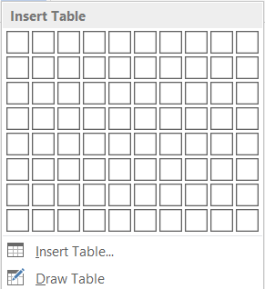

**Design**

Baned Row /Baned Column

|  |  |  |  |
| --- | --- | --- | --- |
| NAME | SALARY | DESIGNATION | STATUS |
| AMIT | **15000`** | **MANAGER** | **YES** |
| ANANT | **29000** | **SR NANAGER** | **YES** |
| SUMAN | **1234** | **PEON** | **YES** |

Table Styles | Shading | Border Style | Pen Color | Border Painter -Try to apply All

**Layout**

**Delete-** Delete Cells, Delete Column, Delete Row, Delete Table

**Insert**

Insert Row Below, Insert Row Above , Insert Column to right , Insert column to left

**Merge Cells-**Merge the selected cells into one cells

**Split cell-**Split the current cell into multiple cell

**Split Table-**Split the table into two tables

**Autofit-**Automatically resize the columns in your table

**Height-** Table Row Height

**Width –** Table Column Width

**Distribute Rows** –Distribute the height of the selected rows equally between them

**Distribute Columns**-Distribute the width of the selected column equally between them

**Alignment-** Top Left , Top Center , Top Right , Center Left , Center , Center Right , Bottom Left ,Bottom Center , Bottom Right

**Text Direction-** Change the text direction within the selected cell

**Cell Margins-**Customize the Cell margins and spacing between them

**Sort-** Arrange the current selection in alphabetical or numerical order

**Convert Text** – Convert the table to regular Text

**Pictures**-Insert pictures from your Computer

Try to Format Picture –Remove Background, Color etc



**Online Pictures-**Find and insert pictures from a variety of online sources

**Shapes-**Insert readymade shapes such as circle , oval etc

**SmartArt-**Insert a smart art graphic

**Screenshot-**Quick add snapshot

**Online Video**-Find and insert a video from online sources

**Links**

**HyperLink-**Create a link in your document for quickly access to web pages and files,it can also take you to place in your document such as headings ,bookmark etc

Hyperlink - Shortcut –Ctrl+K

Step –Want to open a File from my hard drive

Click on insert-hyperlink-(under **text to display** write friendly name of your choice) then

Under **Look in**- select the file from your hard drive to open under **Address** file path automatically present-ok

Step-Want to open a Web URL

Click on insert-hyperlink-(under **text to display** write friendly name of your choice) then under **Address –** write the url example- [**www.innozant.com**](http://www.innozant.com) **or** [**www.google.com**](http://www.google.com)then ok

Step-Want to go to Top of the page

Click on insert-hyperlink-(under **text to display** write friendly name of your choice) then

**Under Place in This Document –** Select Top of the document

**BookMark-**Bookmark works with hyperlinks to let you jump to a specific place in your document

Step

First select the text/item from the current pages you want to put bookmark there then goto Insert-Bookmark-BookMark Name(write name of your choice)-Add

After adding bookmark if you want to goto particular bookmark then click on bookmark->select bookmark from list then GOTO

**Cross Reference-**Refer to your specific places in your document such as headings,tables etc

Step-

Insert-Cross Reference-Under Reference type select heading or bookmark then Insert, Repeat this process for the number of bookmark you added. It shows you as index List of bookmark

**Comment-** Add a note about this part of the document

**Header-**Header helps you to repeat content at the top of every page

**Footer-** Header helps you to repeat content at the bottom of every page

**Page Number** – Number the pages in your document

**Text Box –** Use to showcasing important data such as heading

**MY BIOGRAPHY**

**Innozant**

**WordArt**

**Drop Cap**

T

he times of india published a news , Ravi Shastri, head coach of Indian cricket team, revealed that sending MS Dhoni to bat at No. 7 in their 18-run World Cup semifinal loss to New Zealand was a team decision. India while chasing the modest 240 during the first semi-final were blown away by the Kiwi bowlers led by Matt Henry (3/37) on the reserve day. India’s top-order batsmen were out for just 24 runs inside 10 overs.

Drop Cap-Drop 3 Lines by default maximum upto 10 lines

Object – Insert an embedded object such as another word document, excel sheet or chart



**DESIGN TAB**

**Water Mark-**Add ghost text such as confidential or urgent behind the content on the page

**Page Color-**Add a splash of color to your document by changing the color of the page

**Page Border-**Add or change the border around the page

**PAGE LAYOUT**

**Margins**-Set the margin sizes for the entire document

**Custom Margins-** Left ,Right , Top , Bottom

**Orientation-** Give your pages a portrait or landscape layout

* 1. Portrait
  2. Landscape

**Size –** Choose Page Size

1. Letter
2. A4
3. A3

**Columns** – Split your text into two or more columns

The times of india published a news , Ravi Shastri, head coach of Indian cricket team, revealed that sending MS Dhoni to bat at No. 7 in their 18-run World Cup semifinal loss to New Zealand was a team decision. India while chasing the modest 240 during the first semi-final were blown away by the Kiwi bowlers led by Matt Henry (3/37) on the reserve day. India’s top-order batsmen were out for just 24 runs inside 10 overs.

Bring Forward , Send Backward , Group

INNOZANT

INNOZANT ACADEMY

**REEFERENCES TAB**

**Table of Contents -** Provide an overview of your document by adding a table of contents

# Ms office

### Ms Word

### Ms Powerpoint

### Ms Excel

# Software Development

### Java

### PHP

### Android

# Web Designing

### HTML

### CSS

### JQuery

Step to Make a table of contents

First of all select category (ex-Ms office, Software development, web designing) from above mentioned example and Make them Heading –Goto Home Tab (Heading 1) Now select Subheading from above mentioned example and Label it by going Reference Tab-Add Text-Level3 (Any),Now put the active cursor where you want the table of content , Then Click on Table of Contents-Automatic Table2.

If you want to add more item to the table of content then again label it from Reference-Add text-Level3

**Insert Footnote-**Add a note at the bottom of the page providing more info about something in your document

Example : Just Select below mentioned word ex- (Dos) then references-Insert Footnotes and write the details about it.

Dos[1]

Windows[2]

**Insert Citation –** Credit a source of information by citing the book, article or other material it comes from

**Bibliography**-List all your sources in a bibliography

**Manage Sources** – Organize the sources cited in your document

**Insert Caption**- Label your picture or object

Steps- Insert every pictures one by one then click on insert caption and give name one by one now click

Put the active cursor over there you want Picture index list ,Click on Insert Table of Figures-OK

Figure 1 14

Figure 2 14

Figure 3 14



Figure 1



Figure 2

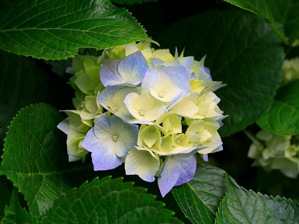

Figure 3

**Mark Entry- (Alt+Shift+X)** – Add the selected text to the index

Steps- make a list of items, then select single item and goto mark entry,Under Main Entry click the cursor and click on Mark, Repeat this process for all the selected item one by one ,Put the active cursor over there you want index list then click on Insert Index Under Format click (Fancy or any) -OK

A

Afgan, 15

Australia, 15

B

Bhutan, 15

Britain, 15

C

Canada, 15

E

England, 15

I

India, 15

Indonesia, 15

India

Australia

Afgan

Canada

Britain

Indonesia

England

Bhutan

**Mark Citation-(Alt+Shift+I)**- Add the selected text to the Table of Authorities

Step- Make a List of item ,Goto Mark Citation-Category-Click any category and replace with the category you want to create(in case of our example category name is Garments,Fruites,Color) Now Select a item-mark citation (Under short citation just click )and choose the category from where the item is –Mark. Repeat this process for every item one by one for each category,Now put the active cursor where you want the index list,Click on Insert Table of Authorities –Format-Classic-OK

Fruites

Apple 16

Banana 16

Mango 16

Color

Blue 16

Green 16

Red 16

Garments

Pant 16

Shirt 16

Tshirt 16

Pant

Shirt

Tshirt

Red

Blue

Green

Mango

Banana

Apple

**MAILING TAB**

**Envelopes-**Sending Mail,You’ll need an envelop

Step-Click on Mailings-Envelop-Write Delivery Address, Return Address-OK

**Labels-**Sending Mails, You’ll Need a label

Steps-Click on Labels-Under options-choose label vender(i.e. how many labels you want in a single page)-New Document-OK

**Mail Merge-**Create one document and send it to multiple people, You can insert fields like Name or Address. Word will create a copy for each recipient and replace those fields with that persons info.

**Steps (In case we don’t have even Document Format & Recipient List)**

Mailing-Start Mail Merge-Step by Step Mail Merge Wizard-(Select Document Type-Letters)-Next-(Select starting document-Use the current document-Next(Select Recipients-Type a New List)-Create-(Under Customize columns-Choose only those filed you want and add some other field of your choice) Write Data Entries in table(ex-recipients details)-Save Address List(Give Name & save) in any drive.

Next-Write Your Letter-(Start Writing Letter )-Choose Address Block , Greeting Line & More item you want to show-Finish & Merge –Edit Individual-Ok

You may see the no. of Pages created for how many recipient you added.

**Steps (In case we already have Document Format & Recipient List (Excel sheet or Access sheet)**

Open the Ms word Document Format-Mailing-Select Recipients-Use an Existing List-(Open the list from the source location) Now From **Insert Merge Field** add the field name one by one in from of Document Format Field Name-Finish & Merge-Edit Individual-Ok

**REVIEW TAB**

Spelling & Grammar – F7

Define-Ctrl+F7

Thesauru-Shift+F7

Word Count

**New Comment-**Add a note about this part of the document

**Restrict Editing** – Limit how much others can edit and format the document.

**VIEW TAB**

**Ruler** –Show rulers next to your document

**Gridlines-**Show gridlines in the background of the document

**New Window** – Open a second window for your documents

**Arrange All-**Stack your open window so you can see all of them at once

**Split**-See two sections of your document at the same time

View side by side

**Switch Windows** – Alt+TAB

**Macros** – You can automate frequently used task by creating and running macros.

Review-Macro-Record Macro-Macro Name(abc)-Assign Macro to –(Button or Keyboard (ctrl+q)-ok

Your recording is started(Write the data you want to repeat it again and again in another document) Now Stop recording –Macro-stop recording. Now open a blank page and press shortcut you recorded(ctrl+q) to see the recorded macro.

**To Password protect the word document**

Goto File-Info-Protect Document-Encrypt with password-Enter password-ok

1. Disk Operating System
2. Microsoft Windows